**WPA2 Exploit Walkthrough and open WRT deployment**

**Disclaimer**

All activities performed in this walkthrough are performed on authorised equipment owned by the writer. Do not target unauthorised equipment. Do not use this walkthrough for illegal purposes, it is purely for educational purposes.

**Introduction**

Wireless routers in home networks use an authentication scheme to allow for users to enter a password and gain access to the network (Wi-Fi). The mechanism used is commonly WPA2 despite WPA3 being available as older hardware is not compatible. Despite this, WPA2-PSK has an inherit security weakness that binds security to the length and complexity of the password used.

The exploitation process that this walkthrough uses involves using reconnaissance to sniff and capture the target wireless network activities and to perform a de-authentication attack to capture the WPA2-PSK handshake. This can be done regardless of how strong the wireless network security is. The hash value used for authentication is then extracted from this capture and cracked locally using a brute force attack involving hashcat and GPUs.

The consequences of this attack are that an attacker can get the password to the wireless network which can then be used to allow them to authenticate and perform further exploitation activities for malicious purposes. Additionally, an attacker could just perform the de-authentication attack to annoy the target and prevent them from using the wireless network.

**Requirements**

* Working Linux machine (physical or virtual) – Any distro, Kali comes with the packages preinstalled.
* Wi-Fi Adapter
* Authorised WPA2 wireless network

**Walkthrough**

The first thing that must be done to be able to exploit WPA2 is to perform some reconnaissance upon the wireless network being targeted. There are a plethora of methods that can be performed here, ranging from manual to fully automatic. The one that this walkthrough will explore is a semi-manual process using the Aircrack-ng tool suite.

Before the reconnaissance can start however, the system should be updated to the latest package versions provided by the distribution. The package manager varies but Kali Linux being in the Debain family uses apt.

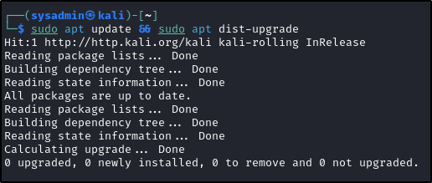

After connecting the Wi-Fi adapter to the Linux machine, the iwconfig program can be used to verify that adapter is working correctly. Some hardware require for additional drivers to be installed and will not work out of the box. The Alfa AWUS036ACH being used for this guide is one of these devices and requires the RTL8812AU driver to allow for the Linux system to interface with the chipset.

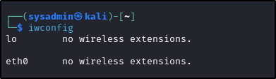

To install this driver, the source code must first be obtained by cloning the git repo from GitHub.

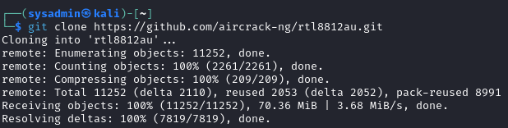

Additionally, the system must have the needed development packages that are requirement to compile the driver.

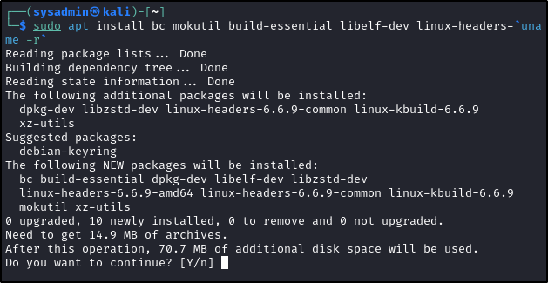

An interesting note that should be mentioned here is the xz-utils package that’s being pulled in a dependency. Andres Freund recently revealed that the most recent development versions of the XZ package contained a backdoor in its library code that some distributions were using with SSH as part of compression functionality. More information can be found by browsing the mail list found [here](https://www.openwall.com/lists/oss-security/2024/03/29/4). It was also later identified that this was done by a recent (2ish years) maintainer of the XZ project. Thus, at the time of writing, its unknown if XZ contains other malicious code and should be treated with caution until further notice.

Regardless of the situation, the driver can be compiled by changed into the directory containing the source code (the one that was just cloned using Git) and using the GNU auto tools to handle the compilation process. Note that `make install` may need a higher privilege level and thus may be required to be run with the `sudo` prefix like with previous commands or as root.

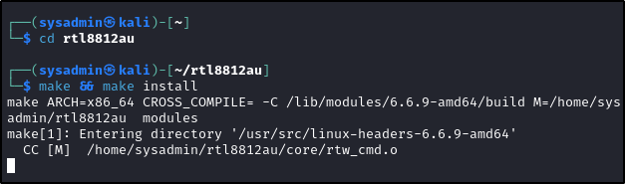

After rebooting, the iwconfig command can be used to verify that the driver is successfully installed, and the wireless card can be accessed.

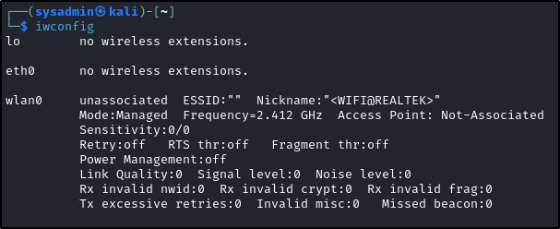

The final task that must be performed before the reconnaissance can start is to switch the Wi-Fi adapter into monitor mode. This is a special state that allows for all wireless traffic within range to be monitored without having to authenticate against the wireless network first. To switch into this state, first airmon-ng can be used to terminate any running processes that may interfere with the operation. Monitor mode can then be successfully enabled using the airmon-ng command against the name of the adapter interface (by default wlan0).

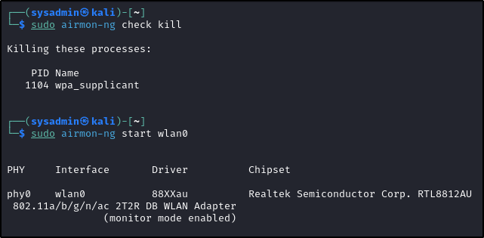

Finally, to begin the reconnaissance the airodump-ng command can be used to listen and list every available wireless network the wireless adapter can reach. This command takes over the terminal and will constantly refresh its results, the q button can be pressed twice to exit back to the terminal.

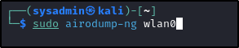

The output from this command can be seen below, with the MAC addresses redacted. As shown, a list of available wireless networks and associated stations (colloquially known as clients). The wireless network that this walkthrough is targeting has been left partially uncensored. The ESSSID (name of the network) can be seen as “VM734980-2G” and the first half of the MAC address (OUI) can be seen as 20:0C:C8. The full MAC address of the target wireless network must be noted as its used in the next steps.

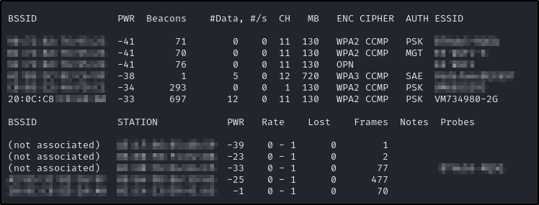

While this is great for browsing, the attack should only happen to the specific target network. To make the results clearer, airodump-ng can be honed in on specific characteristics. By default, this program will iterate through all available channels, but as the target network’s channel is known (11 – can be seen under the “CH” column in the previous screenshot) and can be specified using the -c flag. Additionally, the –bssid flag is being used to only view the target wireless network by its MAC address that was previously recorded in the last step. Finally, the -w flag followed by “capture” is using to record the findings to disk in a file called “capture”. Any text can be used here.



As shown below, only the target network and its clients (only one connected) can be seen.

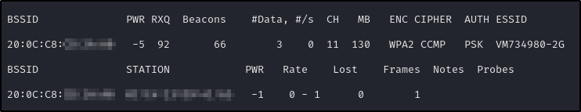

The next stage is to de-authenticate the client so that it reconnects back to the wireless router and performs its WPA2 handshake authentication in the process. This will allow for airodump to intercept the handshake for later cracking. To perform this attack, the aireplay-ng command can be used with the –deuath parameter set to zero. This just means that a de-authentication attack will be occurring. The -a parameter is used to specify the MAC address of the wireless router that was previously noted. This allows for the attack to be carefully targeted and not involve unauthorised wireless networks. This can be further refined to specific clients using the -c flag and the MAC address of the client. Finally, the name of the interface (wlan0) is provided.

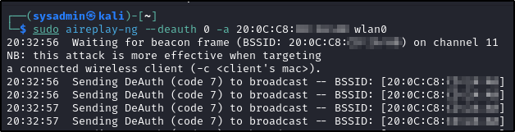

After the client is disconnected and reconnects, ensure that the de-authentication attack is stopped or else it will continue endlessly. Navigating back to the airodump output, successfully capture of the handshake can be verified by the “WPA handshake” followed by the routers MAC address.

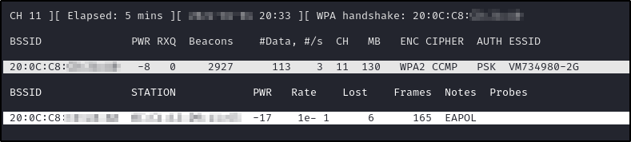

With the WPA2 authentication handshake captured, it can be cracked locally. However, the time needed to crack the password is inherently related to its strength. A password that uses lowercase, uppercase, special characters, and digits while also being 12-14 characters will take an improbable amount of time to crack and is probably not worth the money spent on the computation needed. Alternatively, a dictionary attack could be used if its known that the password isn’t a randomised garbled mess of characters but instead some kind of word.

For demonstration purposes, the captured handshake contained a default password that was eight lowercase characters in length. The cracking process will show how long it take for this particular instance, but in reality, will be longer for recent WPA2 networks as ISPs are most likely increasing the default security of their passwords.

Before this can be cracked, the capture needs to be converted into a format that hashcat understands. This can be done with the hcxtools package.

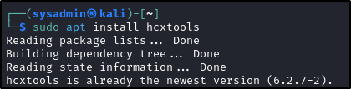

Using the provided hcxpcapngtool provided by this package, the capture can be specified and extracted into a new specified file using the -o flag followed by its name. This file can then be used in hashcat’s processing.

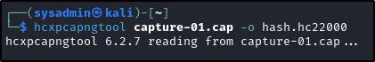

The method of cracking shown next uses a singular instance of a Nvidia H100 GPU from Paperspace with hashcat running on top of it. This is a highly optimised program that can be used for cracking hashes such as the one captured by the WPA2 handshake. Particularly, hashcat has mode 22000 otherwise known as WPA-PBKDF2-PMKID+EAPOL for cracking WPA2 authentication hashes. This can be seen below selected with -m flag. This is followed by the name of the file that contains the WPA2 hash. The -w 3 will increase the workload profile from the default and make hashcat run faster at the expensive of other programs, however as this is the only important program being executed its fine. The -a 3 flag indicates this is a brute force attack followed by the hashcat mask that helps cut down on time. This mask is eight sets of ?l, this indicate a singular lowercase character. Together this indicates that the hash is being crack into a password for eight characters. If it’s known that the wireless router uses a different default password, then a different mask should be used that reflects that.

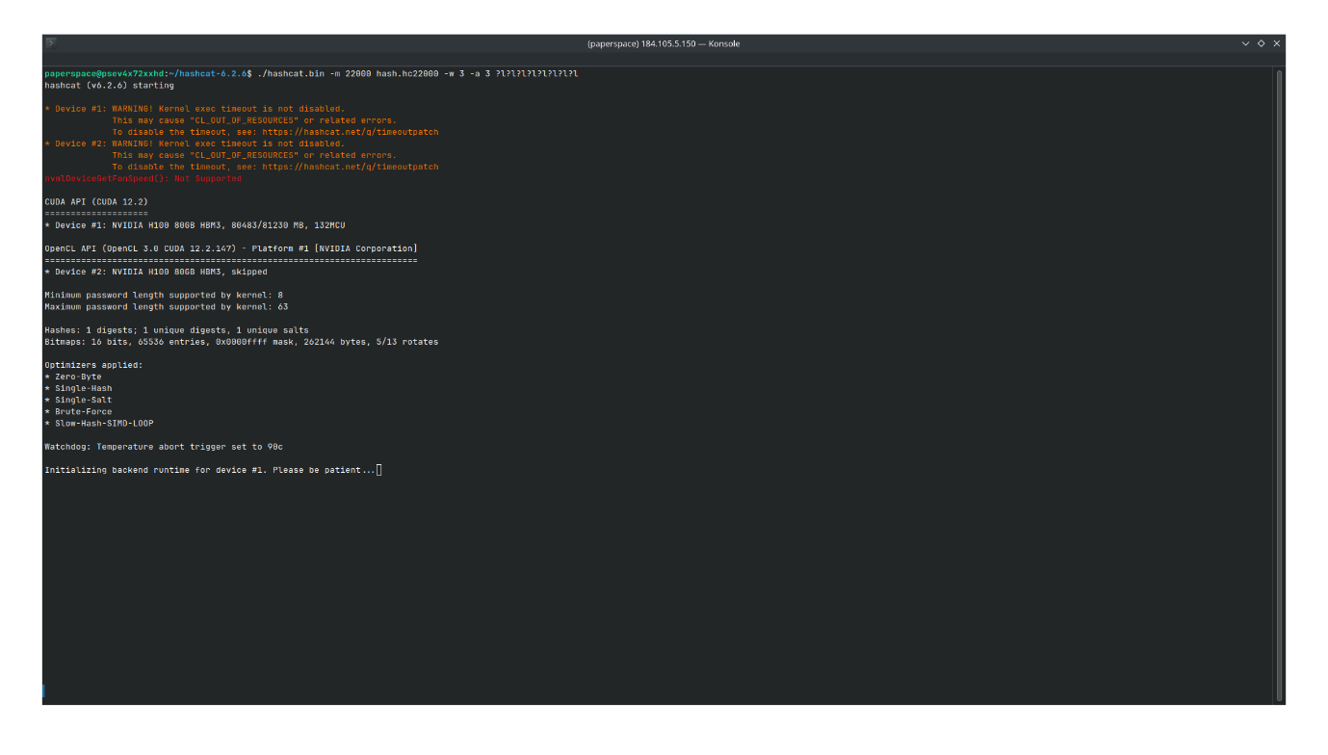

Finally, as shown below, hashcat will crack the hash and reveal the password within 30 hours. Although this wasn’t carried out to completation, the cost can be calculated for cracking this hash. The paperspace H100 instance costs $6 per hour, over 30 hours is $180. This is a lot of money to the individual, but perhaps not so in the grander scheme of things. For instance, this $180 dollars can be used to gain the password and connect to the wireless network which could then be used for further exploitation and malcious activities.

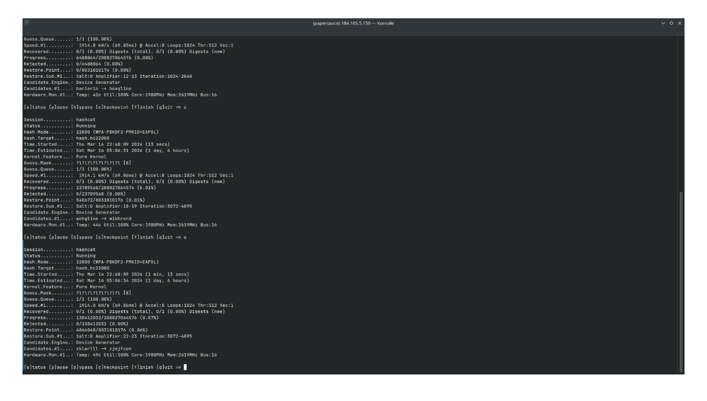

# Remediation

## Introduction

This introduction to remediation using OpenWRT with WPA3 protocol will delve into the specifics of how these technologies work together to safeguard digital communications. We will explore the benefits of upgrading to WPA3, the challenges involved in the transition, and practical guidance on configuring OpenWRT to leverage WPA3 effectively. By the end of this discussion, readers will be equipped with the knowledge to enhance their network security and ensure their systems are resistant to modern cyber threats.

**Requirements**

|  |  |
| --- | --- |
| Hardware | Software |
| Raspberry Pi 4 B with power supply | [openwrt-23.05.0-bcm27xx-bcm2711-rpi-4-squashfs-factory.img](https://openwrt.org/toh/raspberry_pi_foundation/raspberry_pi) |
| Raspberry Pi 5 B with power supply | [openwrt-bcm27xx-bcm2712-rpi-5-ext4-factory.img](https://downloads.openwrt.org/snapshots/targets/bcm27xx/bcm2712/) |
| RJ45 Ethernet capable | [Raspberry PI Imager](https://www.raspberrypi.com/software/) |
| SD card 8GB minimum |  |

This figure illustrates the use of a Raspberry Pi 4 to install OpenWrt and configure the device as a router, intended for educational purposes.

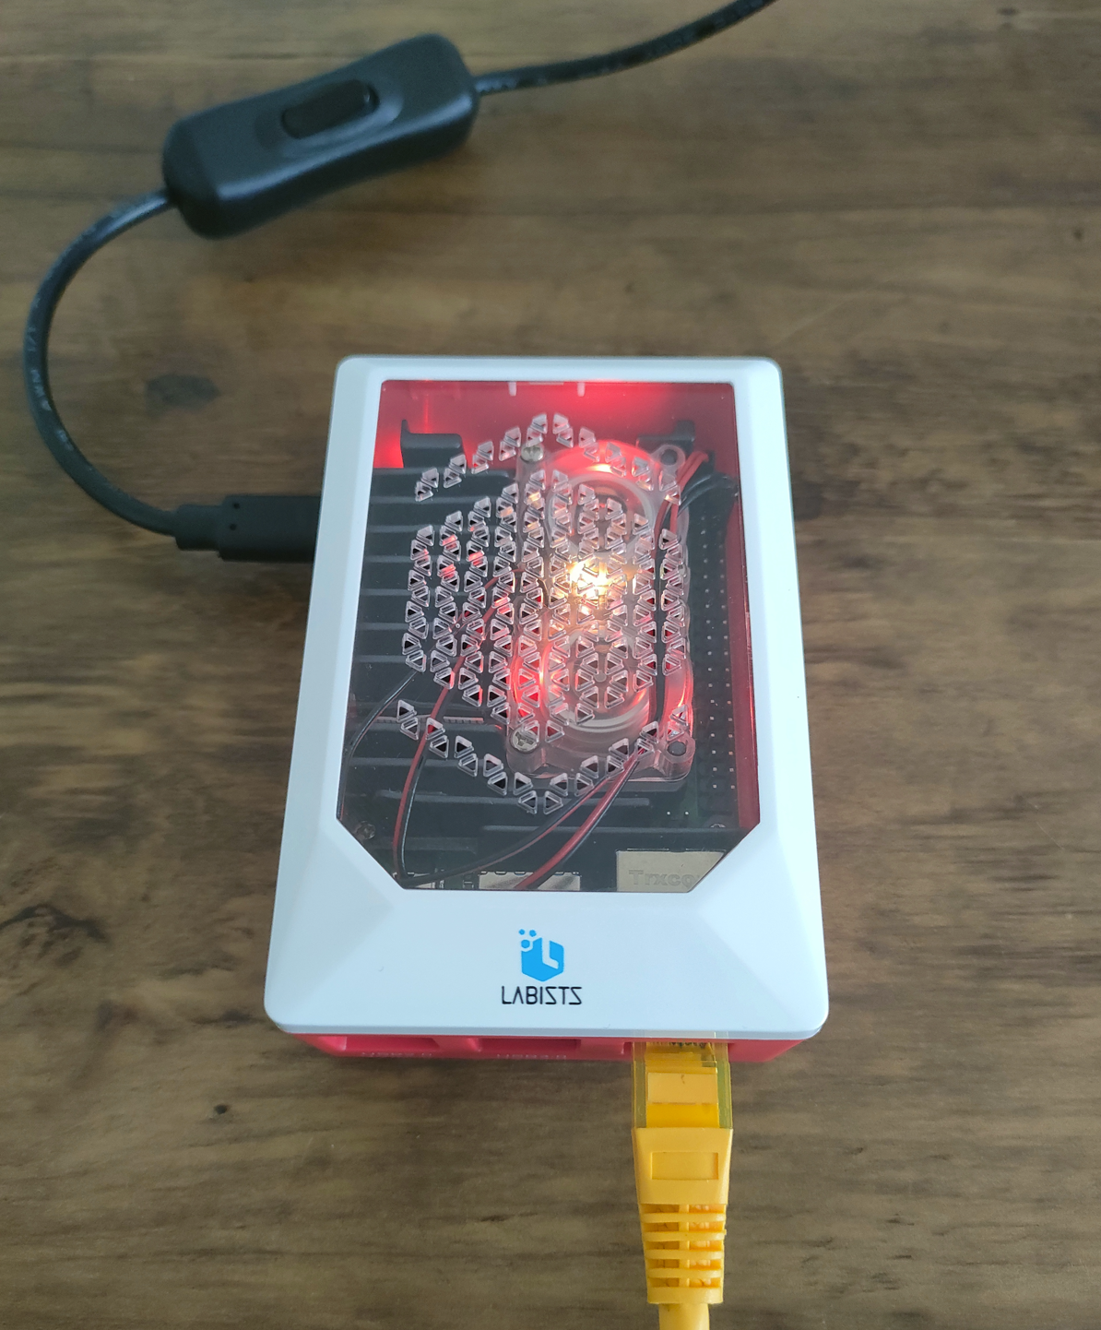

**Walkthrough**

After securing the necessary hardware (note that a single Raspberry Pi, either model 4 or 5, will suffice) download the compatible software for either Raspberry Pi 4 or Raspberry Pi 5, it is time to start the step-up process for OpenWrt. The group will use Raspberry Pi 4 as the hardware platform for this project. The initial step involves preparing the SD card by erasing and formatting it with OpenWrt, using the Raspberry Pi Imager tool.

Figures 1 – 7 will show step-by-step how to erase and format the SD card: -

Figure 1 shows that the user interface is clean and straightforward, making it easy to create an SD card for various Raspberry Pi models. The group will choose the model of their Raspberry Pi, which will be Raspberry Pi 4 and then proceed to the next stages to select the precise OS image to flash onto their SD card.

Figure 1 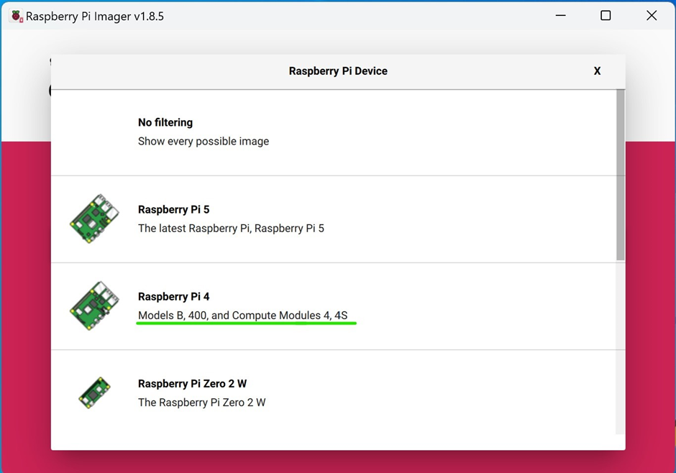

Figure 2 shows that the SD card getting erased, and the SD card is formatted to the FAT32 file system using the Raspberry Pi Imager. FAT32 allows for high compatibility with various operating systems, meeting the Raspberry Pi's bootloader requirements to read the boot partition. FAT32's simplicity and reliability make it ideal for the SD card's boot process, even though other partitions may use various file systems, such as ext4, for the main operating system and storage due to its support for bigger files and more efficient space management.

Figure 2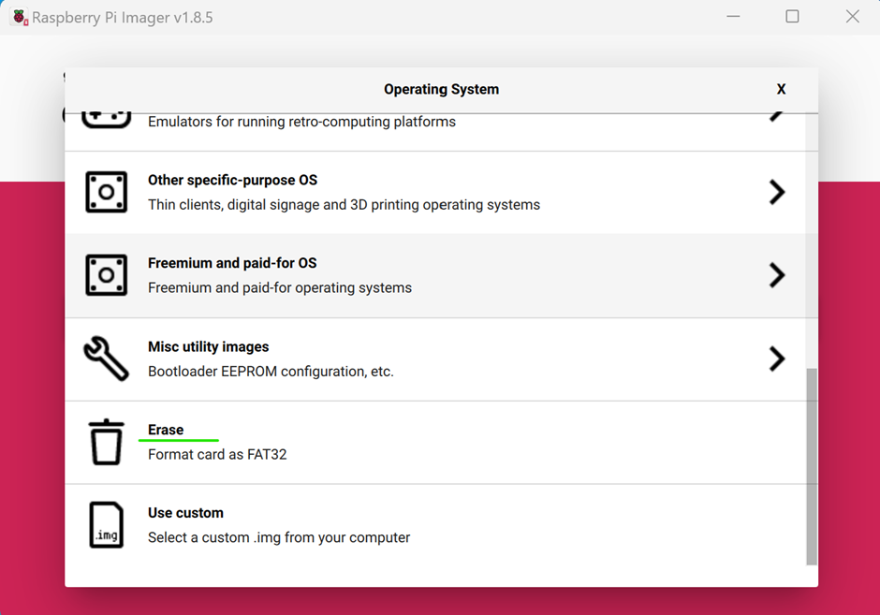

Figure 3 shows the selection of the particular SD card for erasing. by selecting the suitable SD card from a list of possible drives, ensuring that the correct one is erased and formatted for the project. This option is critical for preventing data loss from other discs that may be attached to the computer.

Figure 3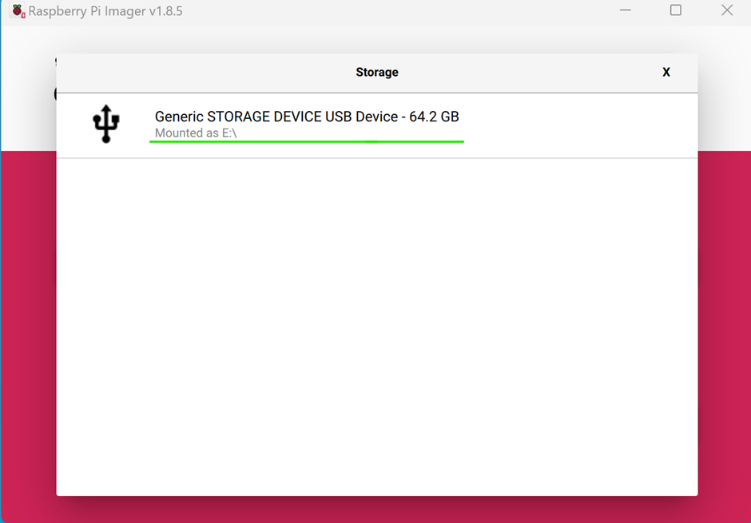

Figure 4 shows the correct option has been selected, and ready to be erase SD card.

Figure 4 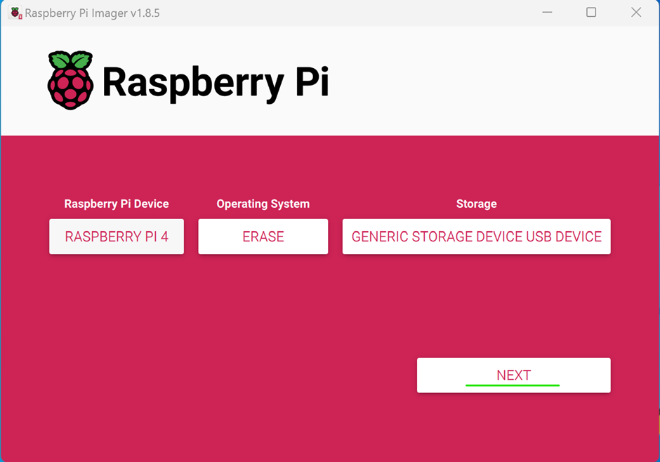

Figure 5 shows after the SD card is ready to be written, go to option use custom and choose OpenWrt.

Figure 5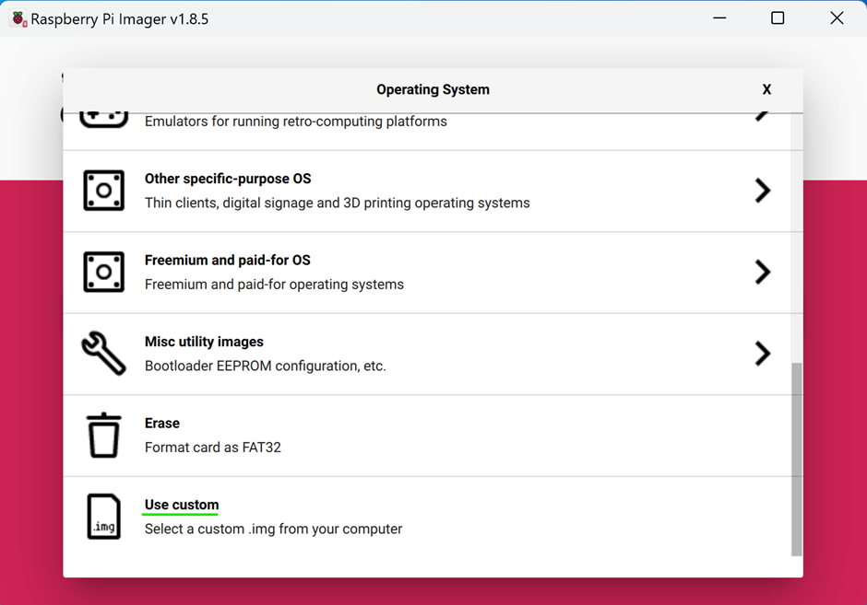

Figure 6 - Figure 6 shows the OpenWrt OS ready for the installation.

Figure 6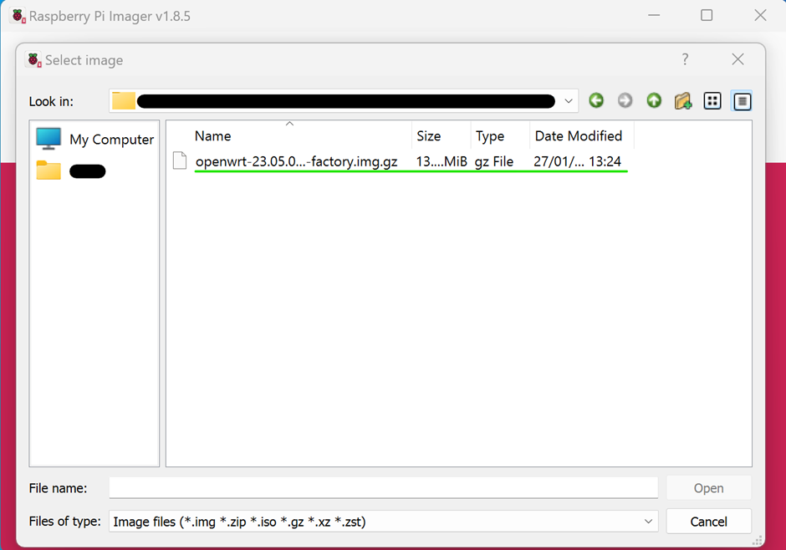

Figure 7 - Figure 7 shows OpenWrt has been installed successfully.

Figure 7 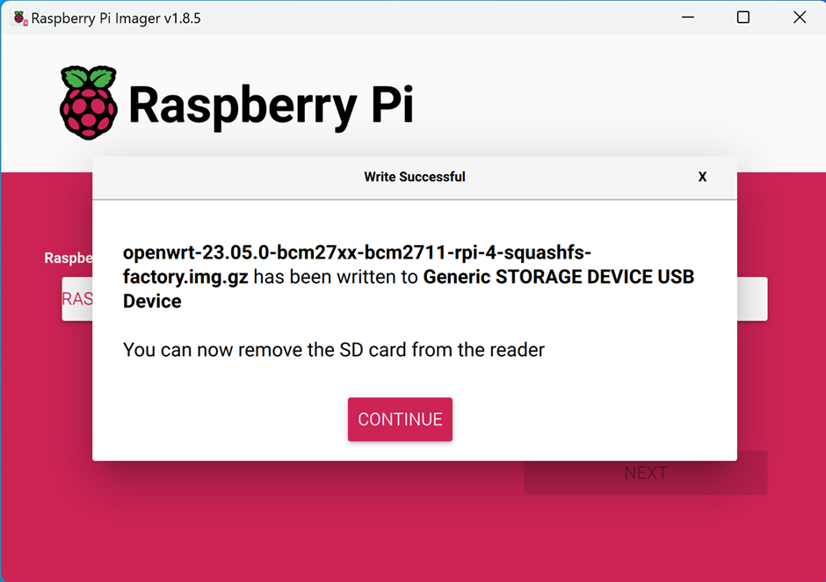

This step shows the network setup required to connect the Raspberry Pi to the computer for configuring OpenWrt.

Figure 8 shows how to setup the network for OpenWrt, by right clicking and selecting properties

Figure 8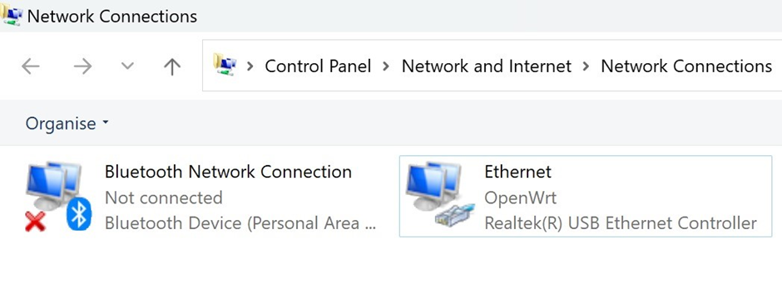

Figure 9 shows the network settings, clicking on Internet Protocol Version 4 and changing the IP Address with the following configuration, will allow the team to log into the OpenWrt admin page the default gateway.

Figure 9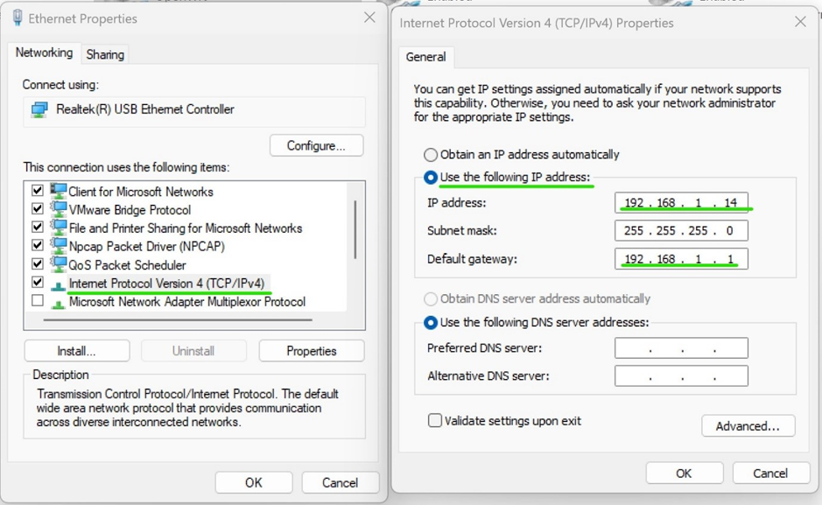

Figure 10 shows a Raspberry Pi 4 connected via an Ethernet cable, through which a group accesses the OpenWrt login page by navigating to the default gateway IP address using a web browser. The login page requires authorization and prompts for a username and password. The username is "root," which is the default for OpenWrt administrative access. This step is crucial for the team to log in and begin configuring the OpenWrt installation.

Figure 10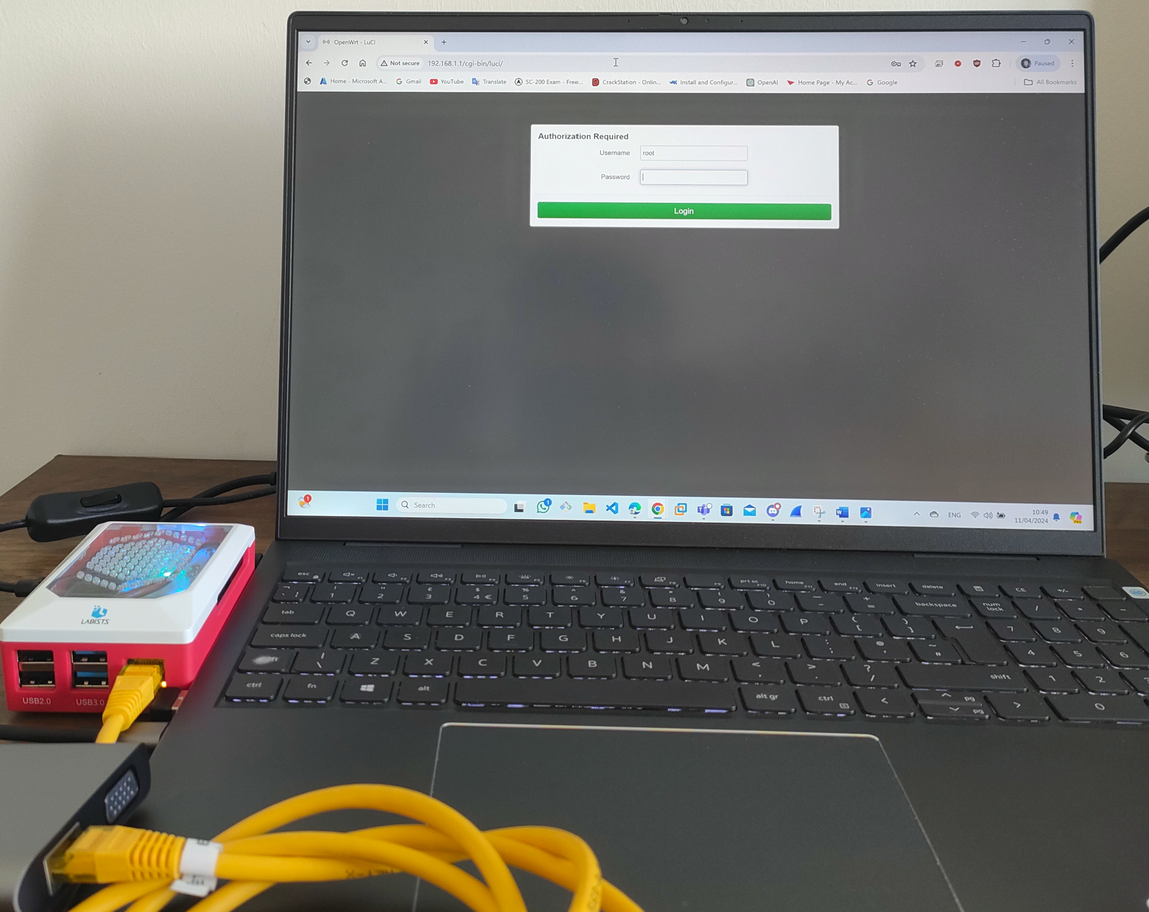

Figure 11 shows OpenWrt's web interface after a successful login, details about the system is shown, such as the hostname being "OpenWrt," the model as a Raspberry Pi 4 Model B Rev 1.4, and various software versions and statuses. Memory usage is detailed, showing a total available memory close to 7.64 GB. The group navigate to the 'Wireless' section, accessible via the 'Network' dropdown menu, where they will have the option to activate the wireless adapter and configure wireless security, including the WPA3 protocol.

Figure 11 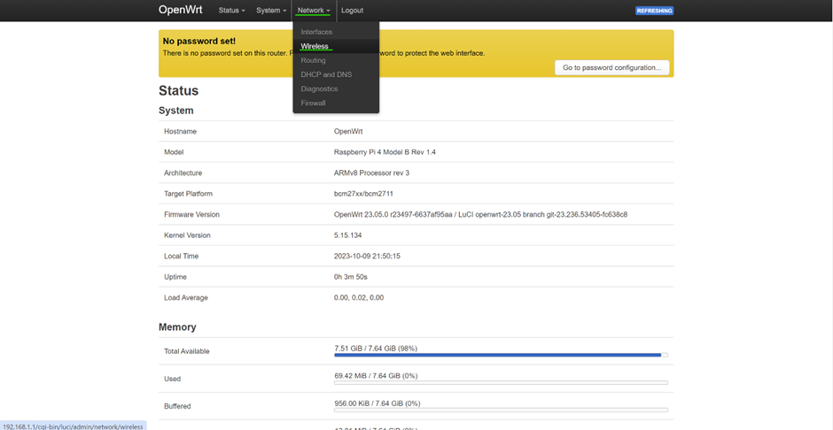

Figure 12 shows that the wireless network interface, named Cypress CYW43455 and supporting the 802.11ac/b/g/n standards, is shown as "not active" and the SSID, "OpenWrt," is as disabled. For the device to broadcast the SSID and become visible to other devices for wireless connectivity, the group will enable the wireless function by clicking the "Enable" button.

Figure 12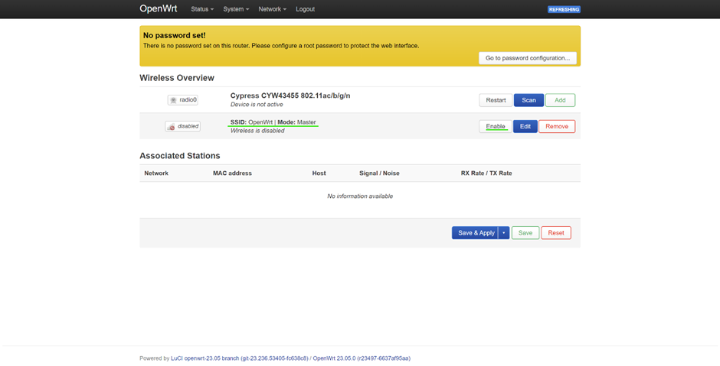

Figure 13 shows the General Setup tab of a wireless network configuration, it shows that the wireless network is enabled, as indicated by the option to "Disable" a sign that the wireless functionality is enabled. The ESSID, which stands for Extended Service Set Identifier, is set to "OpenWrt." This ESSID serves as the network name, and by being set, it allows other wireless-enabled devices to detect and identify this specific OpenWrt network when scanning for available Wi-Fi connections. The details also confirm the network mode as "Access Point," indicating that the device is configured to act as a Wi-Fi hotspot that other devices can connect to.

Figure 13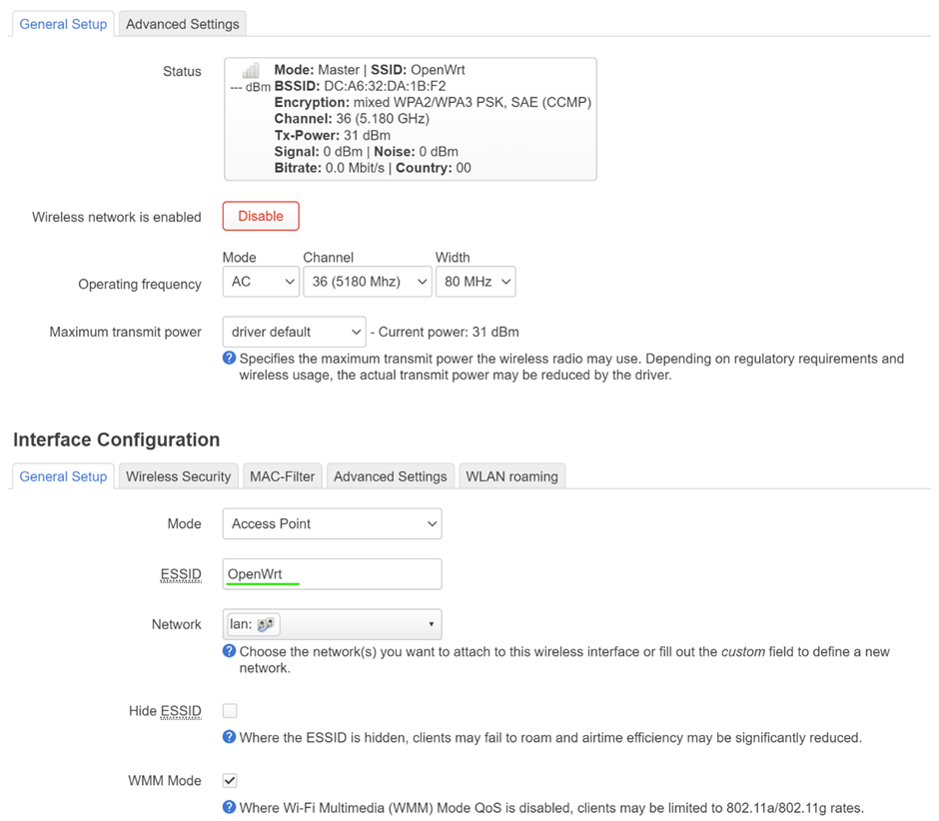

Figure 14 shows that by selecting 'Wireless Security' tab will allow for configuration on the encryption method. The encryption to a mixed mode of WPA2-PSK/WPA3-SAE, which allows for a transition phase accommodating devices that support either encryption standard. Additionally, the wireless password (or key) has been updated to "Ed1nbUrgHN@p13r1964". This new password will be required by devices attempting to connect to the network to verify authorised access, which will enhance the networks.

Figure 14

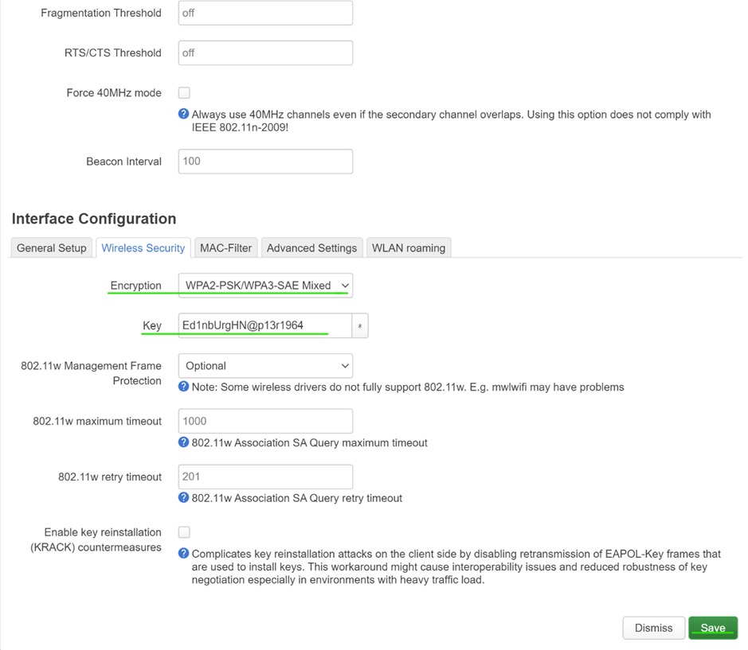

Figure 15 shows the OpenWrt web interface, where the group has made configurations to the wireless settings and by selecting the "Save & Apply" button will make the changes have been made. The wireless summary section shows the SSID as "OpenWrt" with the mode set to "Master," and the encryption as "mixed WPA2/WPA3 PSK, SAE (CCMP),"  that the network will use a secure encryption method. To ensure that these adjustments take effect, the group will need to save and apply them.

Figure 15 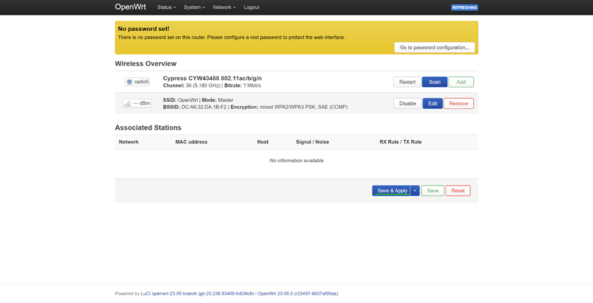

Figure 16 shows that a device with WPA3 compatibility has connected to the OpenWrt access point. The device is "Connected" to the network named "OpenWrt." It is set to automatically reconnect whenever it's within range of this network. The network's signal strength is excellent at -46 dB, and the link speed is reported as 325 Mbps. The security section confirms the use of WPA3-Personal, this proves that the device is using the latest WPA3 security protocol for a secure connection.

Figure 16

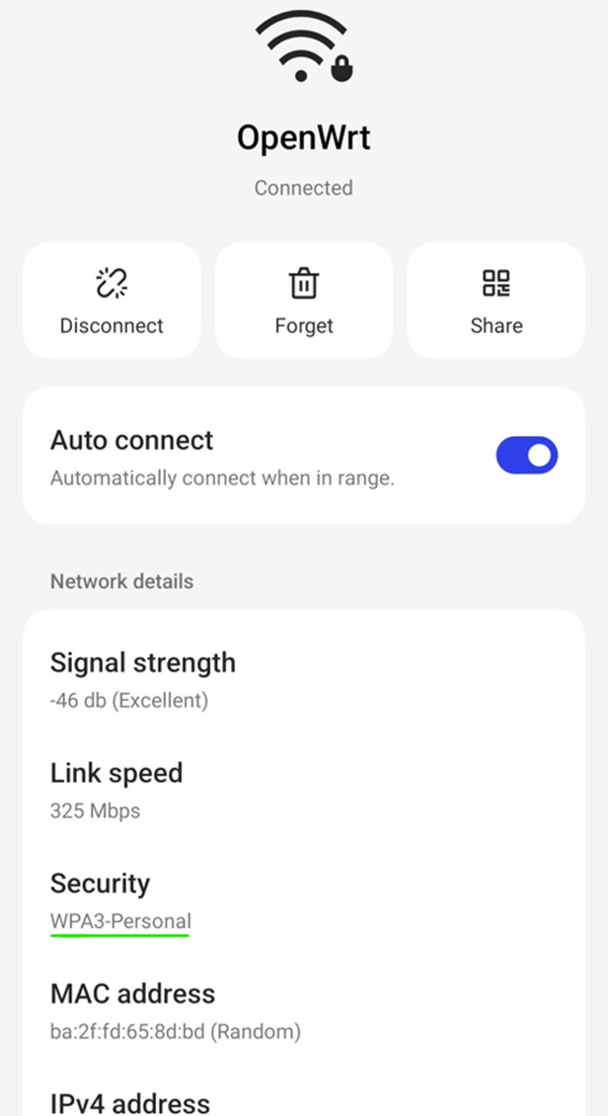

Figure 17 shows that the login password has not yet been established. The group needs to fix this by clicking on the "Go to password configuration" option, which will guide the group through the process of setting a secure password to protect the router’s administrative interface. It is very simple.

Figure 17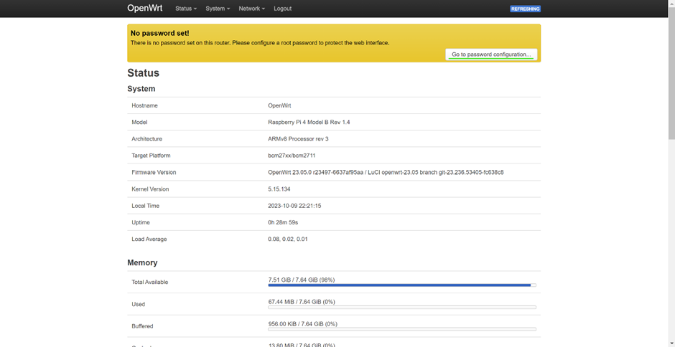

Figure 18 shows the password configuration page, the group has entered a new password for the login page on OpenWrt. The password 'Pr0j3ctWPA3p@2024' has been entered twice for verification and the system agrees the password is secure by stating that the password is 'Strong', its complexity and strength. With 18 characters including upper- and lower-case letters, numbers, and special characters, it provides robust protection against unauthorised access. Once this password is saved, it will serve to fortify the device's web interface security. Once this password is saved, it will help to strengthen the device's web interface security.

Figure 18 